STEM AND LEAF DIAGRAM
Pearson Edexcel - Tuesday 19 May 2020 - Paper 1 (Non-Calculator) Higher Tier
1.
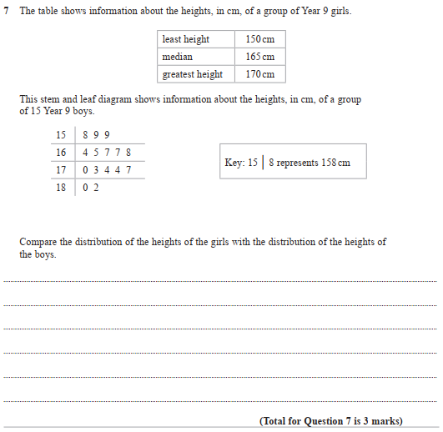

Pearson Edexcel - Friday 6 November 2015 - Paper 2 (Calculator) Higher Tier
2.
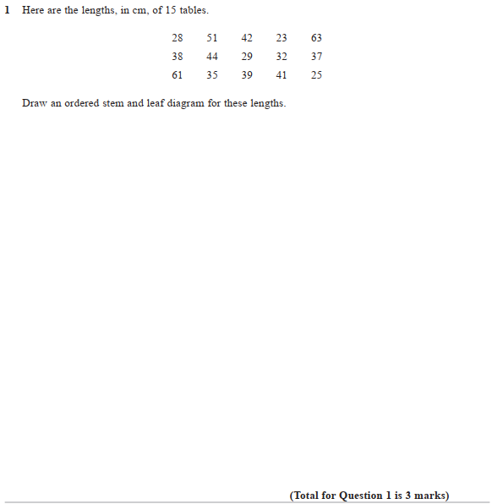

Pearson Edexcel - Thursday 4 June 2015 - Paper 1 (Non-Calculator) Higher Tier
3.
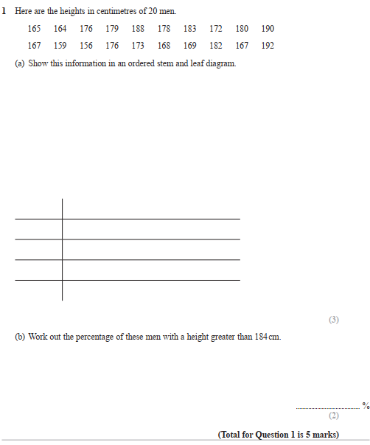

Pearson Edexcel - Wednesday 5 November 2014 - Paper 1 (Non-Calculator) Higher Tier
4.
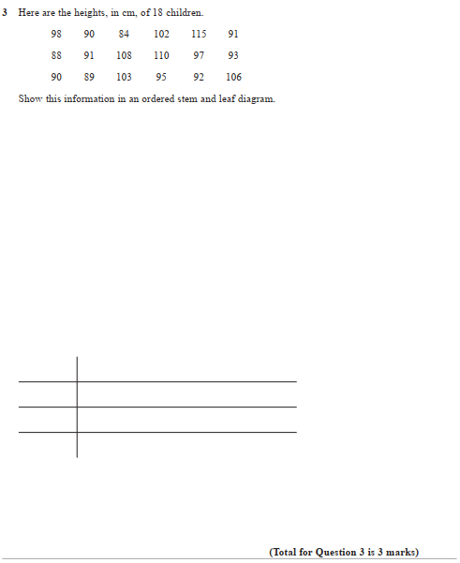

Pearson Edexcel - Monday 9 June 2014 - Paper 1 (Non-Calculator) Higher Tier
5.
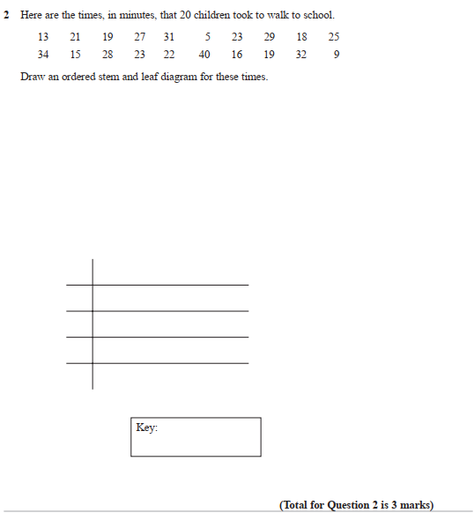

Pearson Edexcel - Tuesday 11 June 2013 - Paper 1 (Non-Calculator) Higher Tier
6.
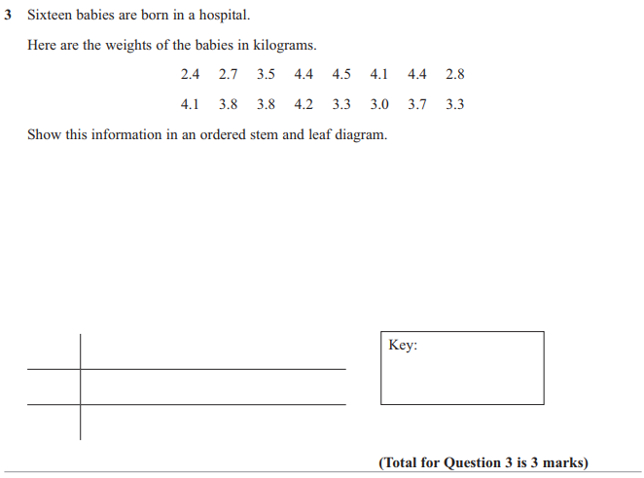

Pearson Edexcel - Monday 4 March 2013 - Paper 2 (Calculator) Higher Tier
7.
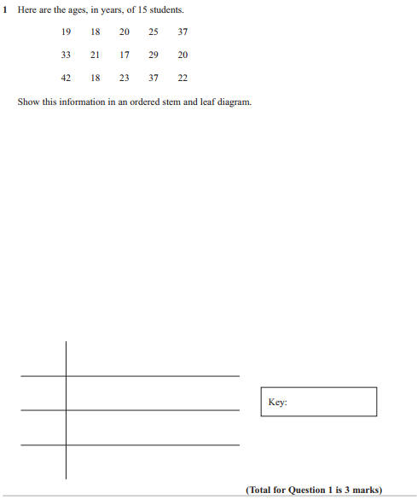

Pearson Edexcel - Thursday 8 November 2012 - Paper 2 (Calculator) Higher Tier
8.
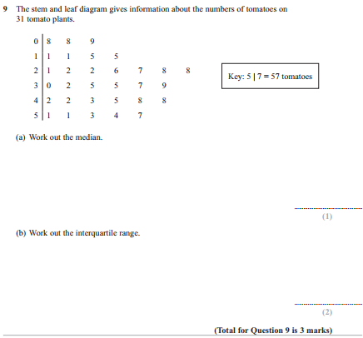

Pearson Edexcel - Monday 11 June 2012 - Paper 1 (Non-Calculator) Higher Tier
9.
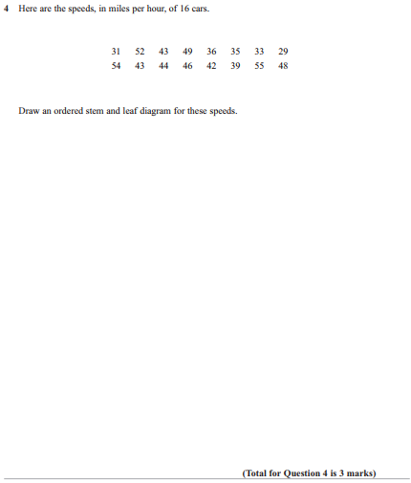

Pearson Edexcel - Friday 2 March 2012 - Paper 3 (Non-Calculator) Higher Tier
10.
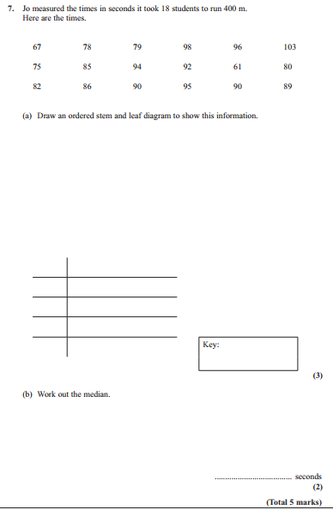

Pearson Edexcel - Wednesday 9 November 2011 - Paper 3 (Non-Calculator) Higher Tier
11.
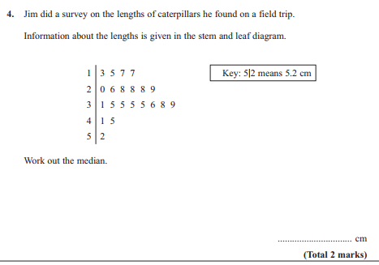

Pearson Edexcel - Friday 10 June 2011 - Paper 4 (Calculator) Higher Tier
12.
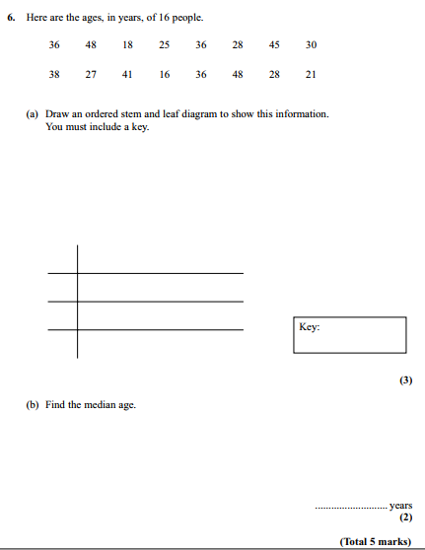

Pearson Edexcel - Tuesday 9 November 2010 - Paper 3 (Non-Calculator) Higher Tier
13.
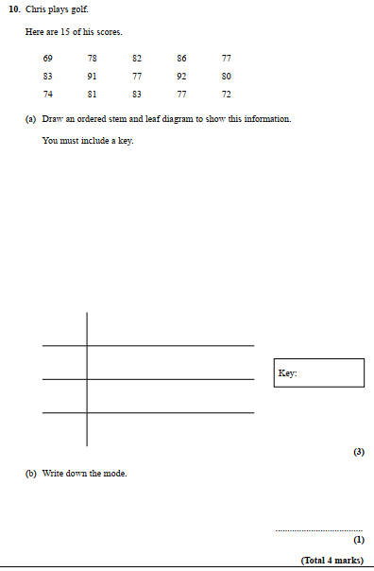

Pearson Edexcel - Monday 7 June 2010 - Paper 3 (Non-Calculator) Higher Tier
14.
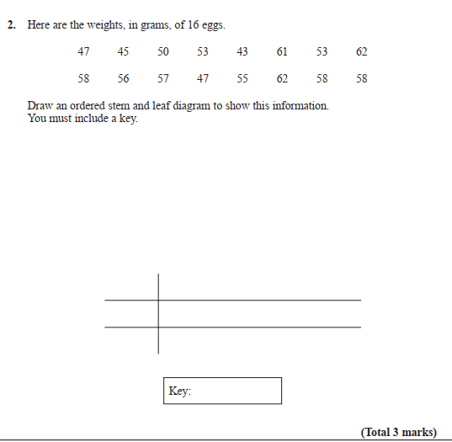

Pearson Edexcel - Thursday 5 November 2009 - Paper 3 (Non-Calculator) Higher Tier
15.
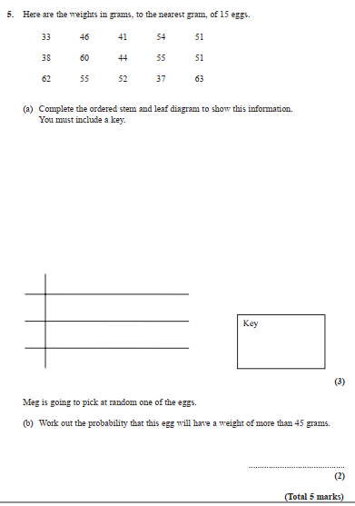
16.

